EXPERIMENT NO. 11 / 12
White-Box Testing & Cyclomatic Complexity Analysis
Project: Hospital Management System (HMS)
Prepared by: Anish Chitnis (24CE1044) | Aaryan Choube (24CE1045) | Somansh Dafade (24CE1047)
Batch: A / A1 | Dept of Computer Engineering, RAIT, DY Patil University
1. Aim
To develop test cases for the Hospital Management System (HMS) using White-Box Testing (Basis Path Testing), construct the Control Flow Graph (CFG), compute McCabe's Cyclomatic Complexity, and achieve 100% statement and branch coverage on the calculateBill() method.
2. Objectives
• To analyze source code logic and construct a Control Flow Graph (CFG).
• To compute McCabe's Cyclomatic Complexity V(G) using all three standard mathematical methods.
• To derive linearly independent basis paths.
• To design test cases with inputs and expected outputs to execute every basis path.
3. Method Under Test: calculateBill()
public class HospitalBillingTest {
public static double calculateBill(double fee, double labCost, boolean hasIns, boolean isEmerg) {
if (fee == 0) { // Node 1 (Predicate 1)
return -1.0; // Node 2 (Error Return)
}
double totalBill = fee + labCost; // Node 3 (Sequential Statement)
if (hasIns || (isEmerg && totalBill > 5000)) { // Node 4 (Predicate 2)
totalBill = totalBill * 0.90; // Node 5 (Apply 10% Discount)
}
return totalBill; // Node 6 (Return Final Bill)
} // Node 7 (Method Exit)
}
4. Control Flow Graph (CFG)
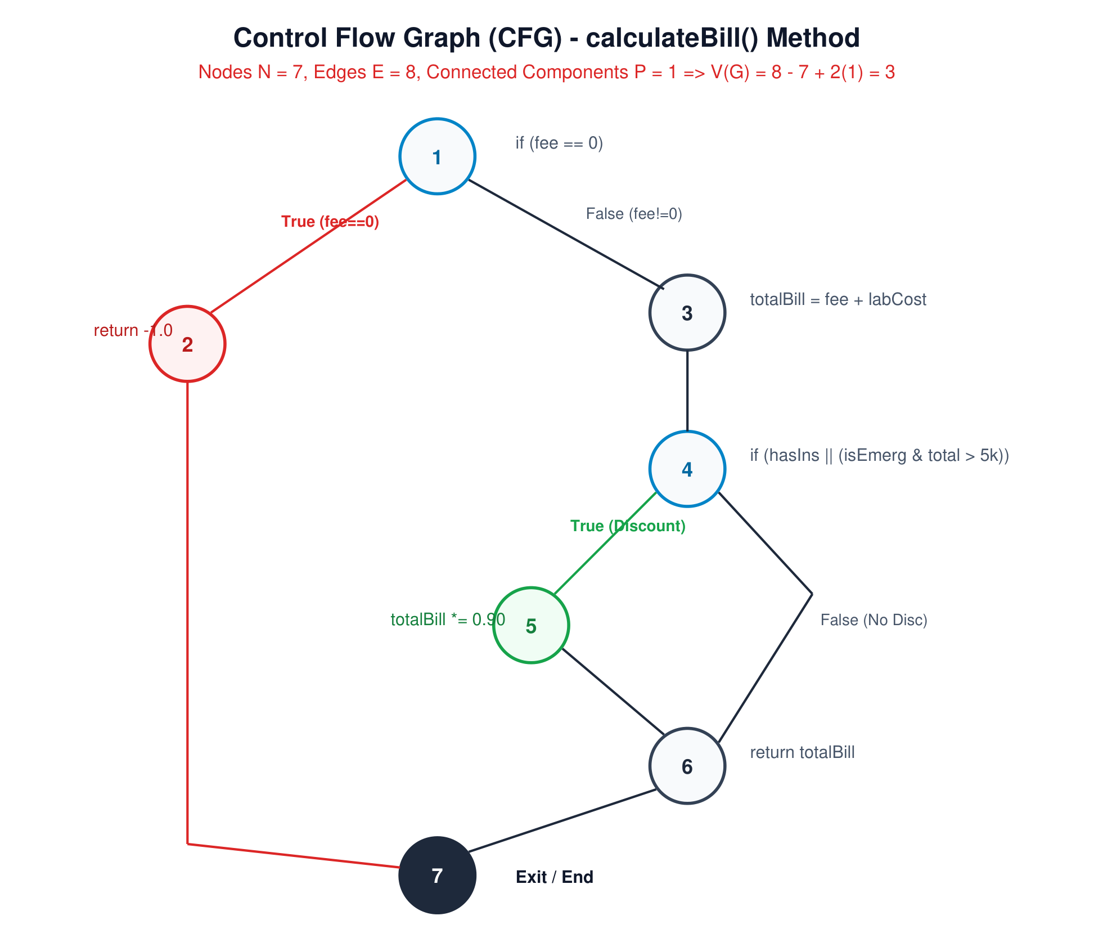
Fig 1: Control Flow Graph (CFG) of calculateBill() Method
5. Cyclomatic Complexity Computation
From the CFG:
• Total Nodes (N) = 7
• Total Edges (E) = 8
• Connected Components (P) = 1
• Predicate Nodes (Pn) = 2 (Node 1: fee==0, Node 4: discount condition)
• Closed Regions (R) = 2
Verification via 3 Independent Methods:
1. Method 1 (Formula: E - N + 2P):
V(G) = 8 - 7 + 2(1) = 3
2. Method 2 (Formula: Pn + 1):
V(G) = 2 + 1 = 3
3. Method 3 (Formula: Closed Regions + 1):
V(G) = 2 + 1 = 3
Therefore, exactly 3 linearly independent basis paths exist, requiring a minimum of 3 test cases for 100% path coverage.
6. Derivation of Basis Paths
• Path 1: 1 ➔ 2 (Invalid consultation fee <= 0; returns error code -1.0)
• Path 2: 1 ➔ 3 ➔ 4 ➔ 5 ➔ 6 ➔ 7 (Valid fee, discount applied via insurance or emergency > 5000)
• Path 3: 1 ➔ 3 ➔ 4 ➔ 6 ➔ 7 (Valid fee, no discount applied; returns standard gross bill)
7. Test Case Suite & Execution Results
Test ID | fee | labCost | hasIns | isEmerg | Expected Output | Actual Output | Path Covered | Status
TC-01 | 0.0 | 1000.0 | false | false | -1.0 (Error) | -1.0 | Path 1 (1->2) | PASSED [OK]
TC-02 | 2000.0 | 3000.0 | true | false | 4500.0 (10% off 5000) | 4500.0 | Path 2 (1->3->4->5->6->7) | PASSED [OK]
TC-03 | 1500.0 | 500.0 | false | false | 2000.0 (No discount) | 2000.0 | Path 3 (1->3->4->6->7) | PASSED [OK]

8. Conclusion
White-box basis path testing verified all execution paths of the calculateBill() method. Cyclomatic complexity V(G) = 3 was satisfied with 100% branch and statement coverage, validating mathematical correctness.

